**Equivalent triangle**

#include <stdio.h>

int main()

{

Int s1, s2, s3;

printf("Enter the sides of the triangle.");

scanf("%d %d %d",&s1, &s2, &s3);

if (s1==s2 && s2==s3)

{

printf ("Equilateral triangle.");

}

else

{

printf("Not an equilateral triangle.");

}

return 0;

}

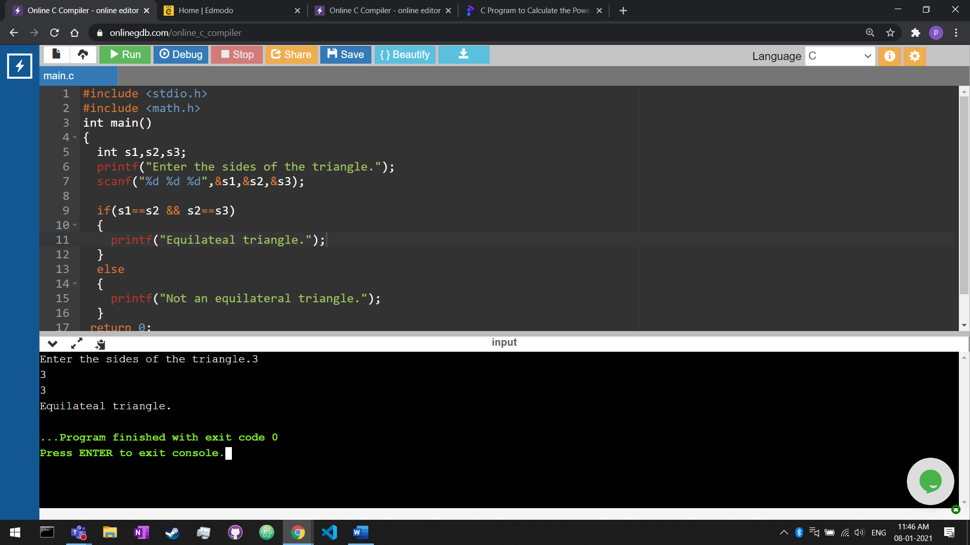

**Integer if odd even**

#include<stdio.h>

int main()

{

int even, odd, num;

printf("Enter the number");

scanf("%d", &num);

if (num%2==0)

{

even=num/2;

printf("The result is:%d", even);

}

else

{

odd=(num*3)+1;

printf("The result is: %d", odd);

}

return 1;

}

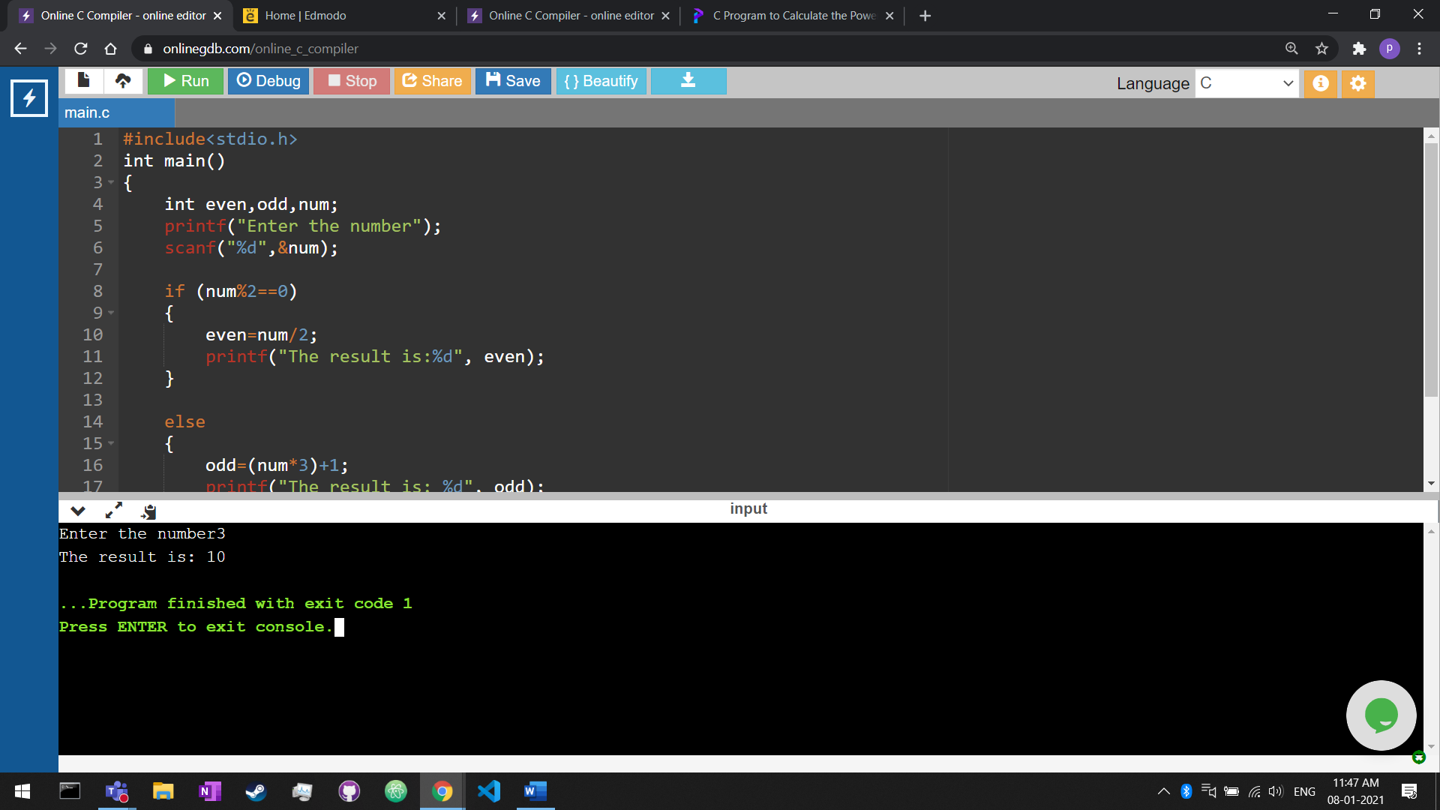

**Simple interest**

#include<stdio.h>

int main()

{

int p, r, t, int_amt;

printf("Input principle, Rate of interest & time to find simple interest: \n");

scanf("%d %d %d" ,&p, &r, &t);

int_amt=(p*r*t)/100;

printf("Simple interest = %d",int_amt);

return 0;

}

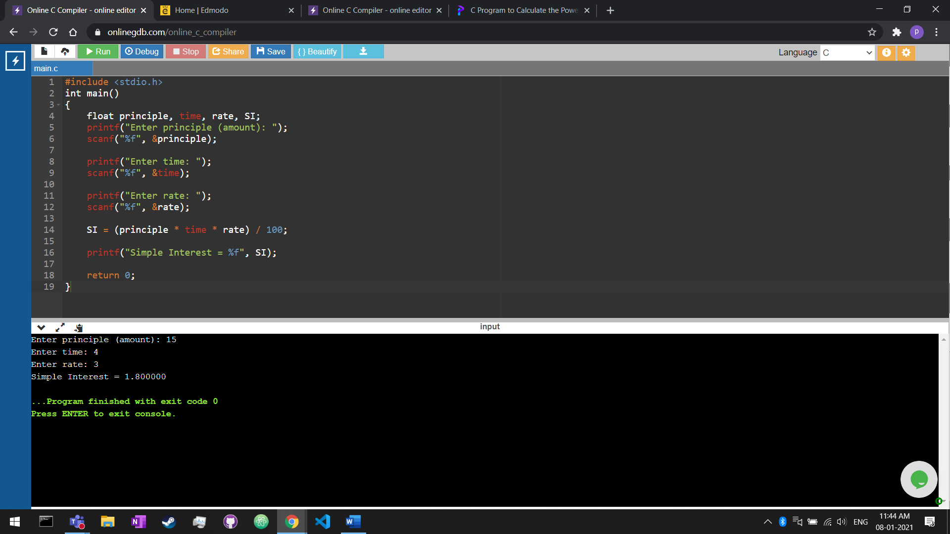

**Unit digit number**

#include <stdio.h>

int main(){

int num, unit;

printf("Enter any number");

scanf("%d", &num);

unit = num % 10;

switch(unit){

case 0:

printf("zero");

break;

case 1:

printf("one");

break;

case 2:

printf("two");

break;

case 3:

printf("three");

break;

case 4:

printf("four");

break;

case 5:

printf("five");

break;

case 6:

printf("six");

break;

case 7:

printf("seven");

break;

case 8:

printf("eight");

break;

case 9:

printf("nine");

break;

default:

printf("invalid input");

break;

}

}

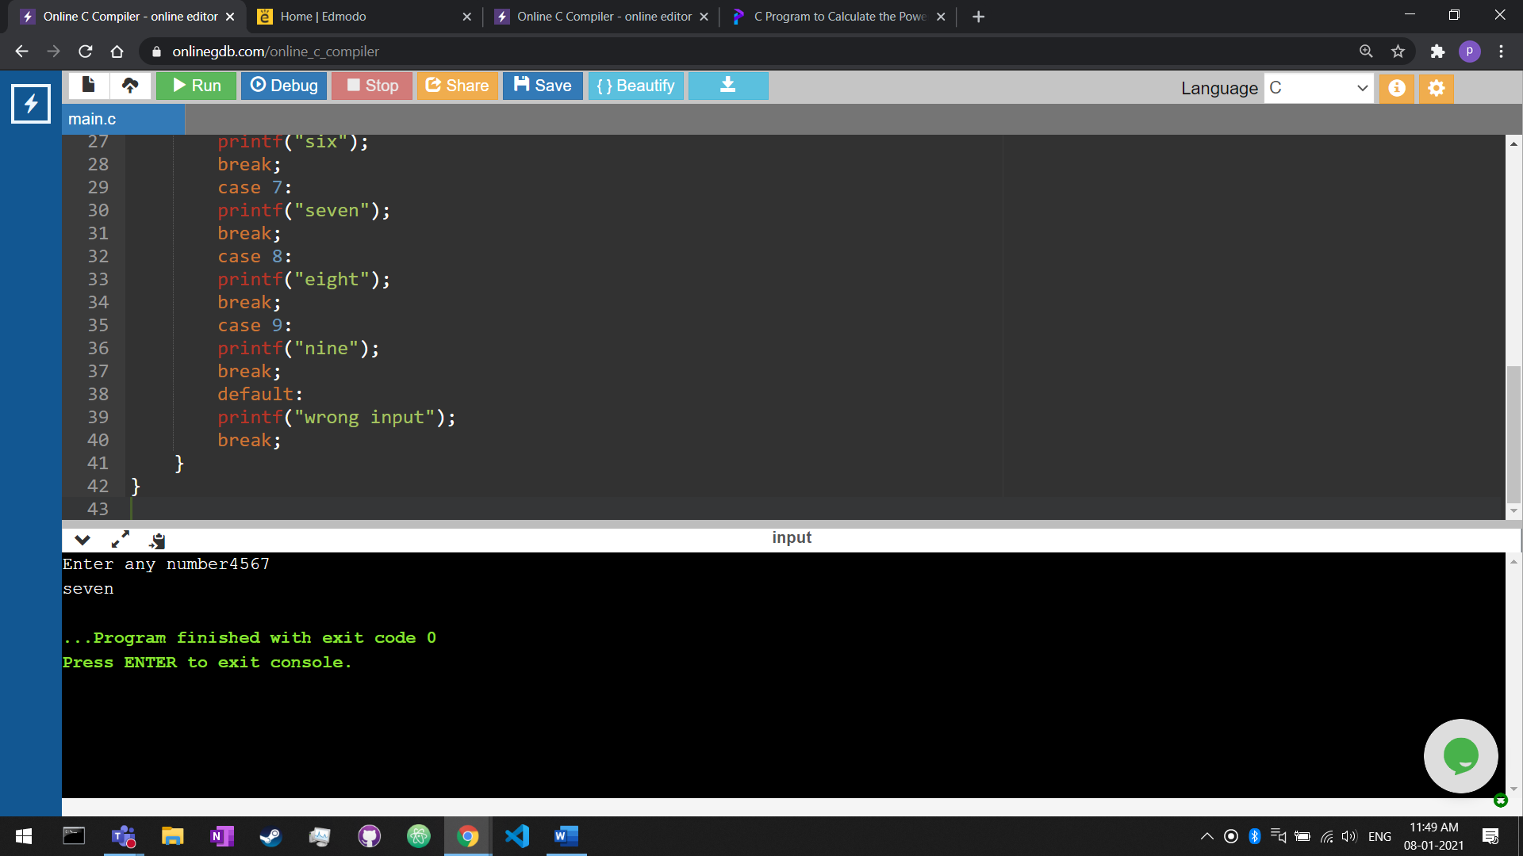

**Leap year**

#include <stdio.h>

int main() {

int year;

printf("Enter a year: ");

scanf("%d", &year);

if (year % 400 == 0) {

printf("%d is a leap year.", year);

}

else if (year % 100 == 0) {

printf("%d is not a leap year.", year);

}

else if (year % 4 == 0) {

printf("%d is a leap year.", year);

}

else {

printf("%d is not a leap year.", year);

}

return 0;

}

